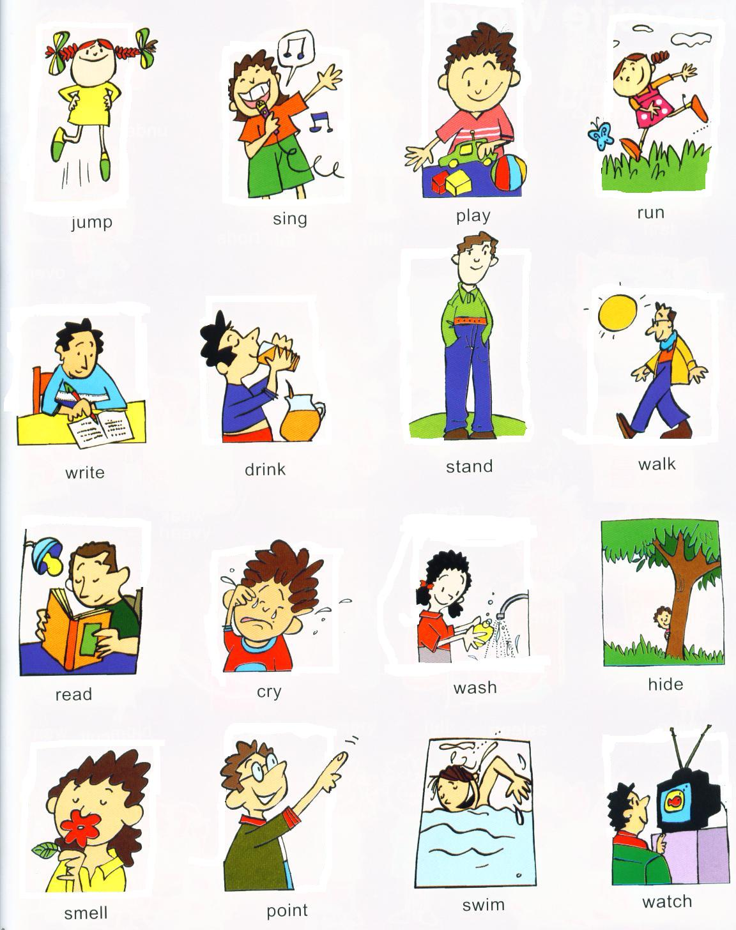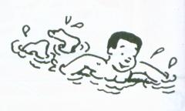

**[](http://images.google.com/imgres?imgurl=http://www.clker.com/cliparts/3/4/c/c/12367305351905413392cut-credit-card.svg.hi.png&imgrefurl=http://www.clker.com/clipart-cut-credit-card.html&usg=__B-kRYzT-bXtXHOstAl04E5XfHu4=&h=455&w=600&sz=86&hl=ar&start=6&um=1&tbnid=ATySWwSWGA2O_M:&tbnh=102&tbnw=135&prev=/images?q=cut+clipart&ndsp=18&hl=ar&lr=&sa=N&um=1)**[](http://images.google.com.eg/imgres?imgurl=http://www.clipartguide.com/_thumbs/0511-0903-1003-0820.jpg&imgrefurl=http://www.clipartguide.com/_search_terms/read.html&usg=__S0clO3A1o6cWD6qvEAipnIz6bUk=&h=98&w=100&sz=8&hl=ar&start=42&um=1&tbnid=TlUDApo90QEHaM:&tbnh=80&tbnw=82&prev=/images?q=read+clipart&ndsp=18&hl=ar&sa=N&start=36&um=1)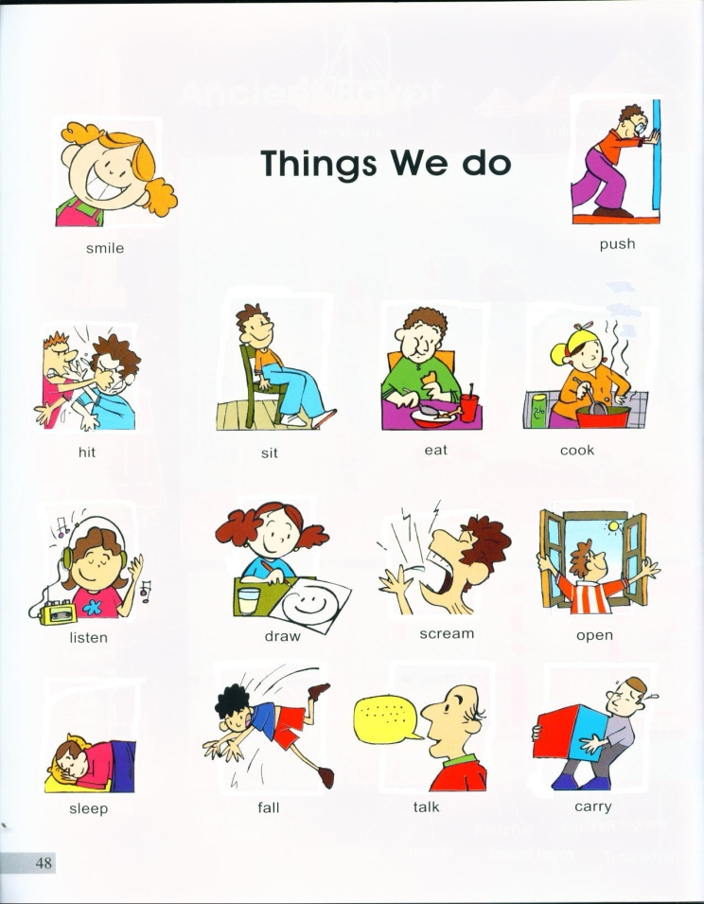

**swim sing draw cut read**

**swim sing draw cut read**

**swim sing draw cut read**

**swim sing draw cut read**

**swim sing draw cut read**

**swim sing draw cut read**

**swim sing draw cut read**

**swim sing draw cut read**

**swim sing draw cut read**

**swim sing draw cut read**

**swim sing draw cut read**

**swim sing draw cut read**

**swim sing draw cut read**

**swim sing draw cut read**

**swim sing draw cut read**

[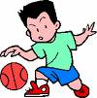](http://images.google.com.eg/imgres?imgurl=http://www.assumption-parish.com/School/images/ClipArt/basketball.gif&imgrefurl=http://www.bostoncrimewatch.com/blog/_archives/2006/12/1/2542455.html&usg=__gp3q9miiuOuZHV3ZM9-O4_2wrWs=&h=182&w=180&sz=4&hl=ar&start=1&um=1&tbnid=2vYUP9CphpaZ9M:&tbnh=101&tbnw=100&prev=/images?q=play+basketball+clipart&um=1&hl=ar&sa=X)**[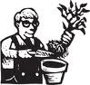](http://images.google.com.eg/imgres?imgurl=http://www.fotosearch.com/bthumb/ARP/ARP116/Hs_Plant.jpg&imgrefurl=http://www.fotosearch.com/clip-art/planting.html&usg=__CiLjDo3_OSIwu_U2CkMXzdNjONk=&h=161&w=170&sz=10&hl=ar&start=31&um=1&tbnid=bFuu6GC_KV6KUM:&tbnh=94&tbnw=99&prev=/images?q=plant+clipart&ndsp=18&hl=ar&sa=N&start=18&um=1)[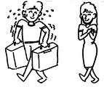](http://images.google.com/imgres?imgurl=http://clear.msu.edu/dennie/clipart/help.gif&imgrefurl=http://clear.msu.edu/dennie/clipart/&usg=__ePxyoe7CW8a9wY3R-c0-aEadPUc=&h=669&w=800&sz=14&hl=ar&start=1&um=1&tbnid=4K5k29C4ExVG2M:&tbnh=120&tbnw=143&prev=/images?q=help++clipart&hl=ar&lr=&um=1)**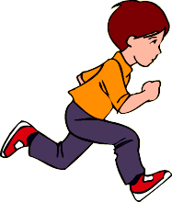

[](http://images.google.com.eg/imgres?imgurl=http://www.clipartheaven.com/clipart/holidays/thanksgiving/thanksgiving-dinner-4-clipart.gif&imgrefurl=http://chasemission.blogspot.com/2008/07/whats-2nd-dinner.html&usg=__k09YXjYPW3MIPZPgcTPsc0xaDWI=&h=446&w=490&sz=13&hl=ar&start=7&um=1&tbnid=4ar9JhmlVO1QxM:&tbnh=118&tbnw=130&prev=/images?q=eat+clipart&hl=ar&um=1)

**help plant run play eat**

**help plant run play eat**

**help plant run play eat**

**help plant run play eat**

**help plant run play eat**

**help plant run play eat**

**help plant run play eat**

**help plant run play eat**

**help plant run play eat**

**help plant run play eat**

**help plant run play eat**

**help plant run play eat**

**help plant run play eat**

**help plant run play eat**

**help plant run play eat**

**help plant run play eat**

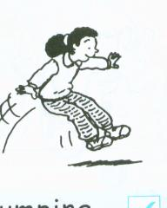

**[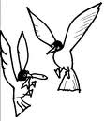](http://images.google.com.eg/imgres?imgurl=http://ngfl.northumberland.gov.uk/clipart/Animals/images/seagulls_jpg.jpg&imgrefurl=http://ngfl.northumberland.gov.uk/clipart/Animals/pages/seagulls_jpg.htm&usg=__JSbRfMZJP7izdyT_9mQcR7CHnss=&h=478&w=410&sz=27&hl=ar&start=31&um=1&tbnid=FEHEsEv2GT2DOM:&tbnh=129&tbnw=111&prev=/images?q=seagull+clipart&ndsp=18&hl=ar&sa=N&start=18&um=1)[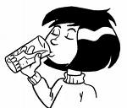](http://images.google.com.eg/imgres?imgurl=http://www.nacdnet.org/education/clipart/DrinkingWater.jpg&imgrefurl=http://www.nacdnet.org/education/clipart/&usg=__aT7Vczqn3FuCtdLMtt2bBpMr_s4=&h=1387&w=1625&sz=169&hl=ar&start=1&um=1&tbnid=SX5OApODZb7wQM:&tbnh=128&tbnw=150&prev=/images?q=drinking+clipart&hl=ar&um=1)[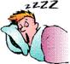](http://images.google.com.eg/imgres?imgurl=http://www.durbinhypnosis.com/images/sleep.gif&imgrefurl=http://www.durbinhypnosis.com/stressmanagement.htm&usg=__fBob8T6DRyBS9YCVbKnlx4ONc0k=&h=92&w=100&sz=6&hl=ar&start=1&um=1&tbnid=Riu9u1HuJ6qM1M:&tbnh=75&tbnw=82&prev=/images?q=sleep&imgtbs=t&imgtype=clipart&hl=ar&sa=G&um=1)[](http://images.google.com.eg/imgres?imgurl=https://www.derbyps.org/uploaded/faculty/james/school_clipart_boy_writting.gif&imgrefurl=http://www.derbyps.org/page.cfm?p=376&usg=__a1f8NecXcg8Qln1Nt5u7E90r4OY=&h=160&w=200&sz=7&hl=ar&start=3&um=1&tbnid=BPyBq6W8sOuRAM:&tbnh=83&tbnw=104&prev=/images?q=write+clipart&hl=ar&um=1)**

**drink sleep jump write fly**

**drink sleep jump write fly**

**drink sleep jump write fly**

**drink sleep jump write fly**

**drink sleep jump write fly**

**drink sleep jump write fly**

**drink sleep jump write fly**

**drink sleep jump write fly**

**drink sleep jump write fly**

**drink sleep jump write fly**

**drink sleep jump write fly**

**drink sleep jump write fly**

**drink sleep jump write fly**

**[](http://images.google.com.eg/imgres?imgurl=http://dclips.fundraw.com/zobo500dir/johnny_automatic_look_it_up.jpg&imgrefurl=http://www.fundraw.com/clipart/clip-art/00003434/Man-Inspecting-Book/&usg=__xvHBNkkWQ-0Fybj04cOwZgbpeNA=&h=500&w=500&sz=45&hl=ar&start=29&um=1&tbnid=rwf9vYXTXCuKQM:&tbnh=130&tbnw=130&prev=/images?q=look+clipart&ndsp=18&hl=ar&sa=N&start=18&um=1)[](http://www.google.com.eg/imgres?imgurl=http://www.arthursclipart.org/children/togethercol/dance.gif&imgrefurl=http://www.arthursclipart.org/children/togethercol.htm&usg=__NQECNatXXfDjP8K4VgqC93liKoA=&h=521&w=391&sz=13&hl=ar&start=3&zoom=1&tbnid=COUNxdtRBE7bPM:&tbnh=131&tbnw=98&ei=8Us4Tai8PMGg8QOL9_ihCA&prev=/images?q=children+dance+clip+art&hl=ar&sa=N&gbv=2&tbs=isch:1&itbs=1)[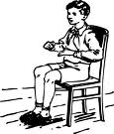](http://www.google.com.eg/imgres?imgurl=http://www.clker.com/cliparts/5/f/8/1/11971067231812192805johnny_automatic_boy_sitting_in_chair.svg.hi.png&imgrefurl=http://www.clker.com/clipart-14728.html&usg=__p-N3UIch4MGjOn20F7ZmNClKkGU=&h=597&w=510&sz=57&hl=ar&start=41&zoom=1&tbnid=MPayPD_HM7SPuM:&tbnh=135&tbnw=115&ei=bkw4TYGLAoGX8QPO6aCZCA&prev=/images?q=sit+clip+art&start=21&hl=ar&sa=N&gbv=2&tbs=isch:1&itbs=1)[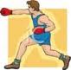](http://www.google.com.eg/imgres?imgurl=http://www.best-of-web.com/_images/080310-162353.jpg&imgrefurl=http://www.best-of-web.com/search_term_pages/hit.html&usg=__zZ8EQf86KbnK40WQmq3vOAi_G9s=&h=99&w=100&sz=3&hl=ar&start=8&zoom=1&tbnid=F642WhOhC2A4NM:&tbnh=81&tbnw=82&ei=7Ew4TcSyKceq8QP2lomwCA&prev=/images?q=hitclip+art&hl=ar&sa=N&gbv=2&tbs=isch:1&itbs=1)[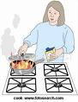](http://images.google.com.eg/imgres?imgurl=http://comps.fotosearch.com/comp/LIF/LIF128/cooking-fire_~Cook.jpg&imgrefurl=http://www.fotosearch.com/LIF128/cook/&usg=__b7uNHt1ZYboINXVavCEJcv_LC60=&h=320&w=247&sz=25&hl=ar&start=31&um=1&tbnid=aRMvG7dxQ5-z5M:&tbnh=118&tbnw=91&prev=/images?q=cook+clipart&ndsp=18&hl=ar&sa=N&start=18&um=1)**

**cook look dance sit hit**

**cook look dance sit hit**

**cook look dance sit hit**

**cook look dance sit hit**

**cook look dance sit hit**

**cook look dance sit hit**

**cook look dance sit hit**

**cook look dance sit hit**

**cook look dance sit hit**

**cook look dance sit hit**

**cook look dance sit hit**

**cook look dance sit hit**

**cook look dance sit hit**

**cook look dance sit hit**

………**ut**

**[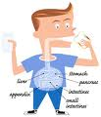](http://www.google.com.eg/imgres?imgurl=http://www.monroepublishing.com/feature/kidshealth/images/gut1.jpg&imgrefurl=http://www.monroepublishing.com/feature/kidshealth/guts.htm&usg=__XtNW6Pfo6bOoA0cmcJX9BSZ_bn4=&h=350&w=300&sz=45&hl=ar&start=12&zoom=1&tbnid=38vz_TvAVS5D2M:&tbnh=120&tbnw=103&ei=WFk4Tb39E4mW8QOks6iZCA&prev=/images?q=gut&hl=ar&sa=N&gbv=2&tbs=isch:1&itbs=1)[](http://images.google.com.eg/imgres?imgurl=http://www.clker.com/cliparts/3/4/c/c/12367305351905413392cut-credit-card.svg.hi.png&imgrefurl=http://www.clker.com/clipart-cut-credit-card.html&usg=__B-kRYzT-bXtXHOstAl04E5XfHu4=&h=455&w=600&sz=86&hl=ar&start=1&um=1&tbnid=ATySWwSWGA2O_M:&tbnh=102&tbnw=135&prev=/images?q=cut++clipart&hl=ar&um=1)[http://tbn3.google.com/images?q=tbn:JhMD8TeaVv1FhM:http://www.thenuthut.com.au/contents/media/clipart.hut.gif](http://images.google.com.eg/imgres?imgurl=http://www.thenuthut.com.au/contents/media/clipart.hut.gif&imgrefurl=http://www.thenuthut.com.au/contents/en-us/about.html&usg=__3JrkNXsy0_kZBEFqH6oT52fAndQ=&h=50&w=73&sz=4&hl=ar&start=7&um=1&tbnid=JhMD8TeaVv1FhM:&tbnh=48&tbnw=70&prev=/images?q=hut++clipart&hl=ar&um=1)[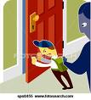](http://images.google.com.eg/imgres?imgurl=http://comps.fotosearch.com/comp/IMZ/IMZ401/boy-pushing-door_~sps0455.jpg&imgrefurl=http://www.fotosearch.com/IMZ401/sps0455/&usg=__rjhpv0QvB0VjhXIJv2gIdDHdFWE=&h=320&w=290&sz=25&hl=ar&start=3&um=1&tbnid=5bzTJlU_Lo5MKM:&tbnh=118&tbnw=107&prev=/images?q=close+door++clipart&ndsp=18&hl=ar&sa=N&um=1)**

[http://tbn0.google.com/images?q=tbn:rBHYjqJdZ2SwpM:http://www.clipartreview.com/_gallery/_TN/r_748.gif](http://images.google.com.eg/imgres?imgurl=http://www.clipartreview.com/_gallery/_TN/r_748.gif&imgrefurl=http://www.clipartreview.com/_gallery/_pages/r_748.html&usg=__wDWo6zSrxhgLHvVxuL_xZv6Ch6M=&h=38&w=150&sz=4&hl=ar&start=13&um=1&tbnid=rBHYjqJdZ2SwpM:&tbnh=24&tbnw=96&prev=/images?q=nut+clipart&hl=ar&um=1)

**nut hut cut shut gut**

**nut hut cut shut gut**

**nut hut cut shut gut**

**nut hut cut shut gut**

**nut hut cut shut gut**

**nut hut cut shut gut**

**nut hut cut shut gut**

**nut hut cut shut gut**

**nut hut cut shut gut**

**nut hut cut shut gut**

**nut hut cut shut gut**

**nut hut cut shut gut**

**similar word** الكلمات المتشابهة

………at

[](http://images.google.com.eg/imgres?imgurl=http://kidsturncentral3.com/clipart/cat3c1.gif&imgrefurl=http://www.kidsturncentral.com/clipart/catclipart1.htm&usg=__aalH-OyPGKNJojt0IRDNvyEGTf4=&h=209&w=200&sz=12&hl=ar&start=9&um=1&tbnid=Nh0xsUUgih_JkM:&tbnh=106&tbnw=101&prev=/images?q=cat+clipart&ndsp=18&hl=ar&sa=N&um=1)**[http://t2.gstatic.com/images?q=tbn:jGwVoA_mu2ssQM:http://www.clipartreview.com/_gallery/_TN/r_209.gif](http://www.google.com.eg/imgres?imgurl=http://www.clipartreview.com/_gallery/_TN/r_209.gif&imgrefurl=http://www.clipartreview.com/_gallery/_search_term_pages/wildlife.html&usg=__b51U57N-DmXgEN6sobOhOGrdhXo=&h=86&w=150&sz=8&hl=ar&start=1&zoom=1&tbnid=jGwVoA_mu2ssQM:&tbnh=55&tbnw=96&ei=lE84TYiUHM-r8QOgpeWjCA&prev=/images?q=ratclip+art&hl=ar&sa=N&gbv=2&tbs=isch:1&itbs=1)[](http://www.google.com.eg/imgres?imgurl=http://www.picturesof.net/_images/fat_boy_with_an_ice_cream_cone_in_each_hand_royalty_free_080803-211539-492020.jpg&imgrefurl=http://www.picturesof.net/search_term_pages/fat_children.html&usg=__T7TXf15P-ica7hBKyLlaI6SsHZw=&h=100&w=79&sz=4&hl=ar&start=3&zoom=1&tbnid=mCDqSGQ4GnENIM:&tbnh=82&tbnw=65&ei=CFA4TeqVEYqr8QP0xsGuCA&prev=/images?q=fat+child+clipart&hl=ar&sa=X&gbv=2&tbs=isch:1&itbs=1)**[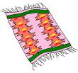](http://www.google.com.eg/imgres?imgurl=http://www.clipart-fr.com/en/data/clipart/objects/clipart_objects_085.gif&imgrefurl=http://en.clipart-fr.com/clipart_pictures.php?id=17803&usg=__rjtQisWBTZf1vGmHVBq1piwYXPY=&h=225&w=240&sz=4&hl=ar&start=16&zoom=1&tbnid=-SbMCwxxEj0qYM:&tbnh=103&tbnw=110&ei=aVA4TYTGBtGp8AOj7smsCA&prev=/images?q=carpet+clipart&hl=ar&sa=X&gbv=2&tbs=isch:1&itbs=1)[](http://images.google.com.eg/imgres?imgurl=http://www.imajlar.com/free_clipart/cowboy_clipart/cowboy_clipart_hat.gif&imgrefurl=http://www.free-clipart-pictures.net/cowboy_clipart.html&usg=__r5_Vaa3oeg0_vqzbIsbuE6oqwDA=&h=137&w=200&sz=5&hl=ar&start=3&um=1&tbnid=FmmVyD97mwEm2M:&tbnh=71&tbnw=104&prev=/images?q=hat++clipart&hl=ar&um=1)[http://tbn1.google.com/images?q=tbn:pX9ZNhW0iWxhkM:http://www.clker.com/cliparts/2/1/0/b/119543705743616174liftarn_Bat.svg.med.png](http://images.google.com.eg/imgres?imgurl=http://www.clker.com/cliparts/2/1/0/b/119543705743616174liftarn_Bat.svg.med.png&imgrefurl=http://www.clker.com/clipart-11382.html&usg=__-nooRTIaxGX0hcYdE6ySNz0S69E=&h=100&w=300&sz=5&hl=ar&start=20&um=1&tbnid=pX9ZNhW0iWxhkM:&tbnh=39&tbnw=116&prev=/images?q=bat++clipart&hl=ar&um=1)

**hat bat cat rat fat mat**

**hat bat cat rat fat mat**

**hat bat cat rat fat mat**

**hat bat cat rat fat mat**

**hat bat cat rat fat mat**

**hat bat cat rat fat mat**

**hat bat cat rat fat mat**

**hat bat cat rat fat mat**

**hat bat cat rat fat mat**

**hat bat cat rat fat mat**

**hat bat cat rat fat mat**

………**un**

**[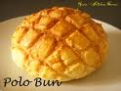](http://www.google.com.eg/imgres?imgurl=http://3.bp.blogspot.com/_HR7DgxmmhdU/SKUcxEW7ioI/AAAAAAAAAz8/HyLeBYK6XS4/s400/polo+bun.jpg&imgrefurl=http://gracekitchencorner.blogspot.com/2008/08/polo-bun.html&usg=__TlDSsJP5REq3OqBEBj-wFc1AyhA=&h=300&w=400&sz=25&hl=ar&start=13&zoom=1&tbnid=hmO_n7pMPDO-gM:&tbnh=93&tbnw=124&ei=IFw4Te2dEY-o8QPe_fmvCA&prev=/images?q=bun&hl=ar&sa=N&gbv=2&tbs=isch:1&itbs=1)[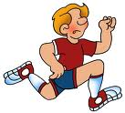](http://www.google.com.eg/imgres?imgurl=http://languageartsgames.4you4free.com/comma_splices_run_ons_small.gif&imgrefurl=http://languageartsgames.4you4free.com/grammar.html&usg=__yw1uU5i9oqYEfpB9OucLNh4ww3I=&h=588&w=648&sz=55&hl=ar&start=18&zoom=1&tbnid=mCCG9UWgmw3BeM:&tbnh=124&tbnw=137&ei=lVs4TZTfJcS48gPwxYCpCA&prev=/images?q=run&hl=ar&sa=N&gbv=2&tbs=isch:1&itbs=1)[](http://www.google.com.eg/imgres?imgurl=http://www.cksinfo.com/clipart/nature/weather/sun/bright-yellow-sun.png&imgrefurl=http://www.cksinfo.com/nature/weather/sun/index.html&usg=__Y-t8BJ2hKMz1NJwl5cVnSSLom1g=&h=335&w=329&sz=22&hl=ar&start=1&zoom=1&tbnid=W4Rfn1Ra50O2AM:&tbnh=119&tbnw=117&ei=Jls4TYXCE8aX8QOC5OSfCA&prev=/images?q=sun&hl=ar&sa=N&gbv=2&tbs=isch:1&itbs=1)[](http://www.google.com.eg/imgres?imgurl=http://departments.bloomu.edu/solve/img\KidsFun.jpg&imgrefurl=http://departments.bloomu.edu/solve/kidsfun.html&usg=__KIigquU0Ei2fdWFHSXCgVBunHC4=&h=412&w=700&sz=45&hl=ar&start=109&zoom=1&tbnid=vP1Asv9W2X3bZM:&tbnh=82&tbnw=140&ei=-ls4TfakM8u38QP88dSoCA&prev=/images?q=fun&start=105&hl=ar&sa=N&gbv=2&tbs=isch:1&itbs=1)[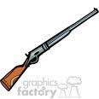](http://www.google.com.eg/imgres?imgurl=http://www.graphicsfactory.com/clip-art/image_files/image/9/1312409-cowboys_4162007-103.gif&imgrefurl=http://www.graphicsfactory.com/Clip_Art/People/Cowboys/cowboys_4162007-103_374218.html&usg=__tTz71aF9IQVkt1k3twqPEkVbx-A=&h=300&w=300&sz=12&hl=ar&start=26&zoom=1&tbnid=6dEXo_dY2SjRAM:&tbnh=116&tbnw=116&ei=mVw4TdGTK8eX8QP35LCjCA&prev=/images?q=gun+clip+art&start=21&hl=ar&sa=N&gbv=2&tbs=isch:1&itbs=1)**

**Sun run bun gun fun**

**Sun run bun gun fun**

**Sun run bun gun fun**

**Sun run bun gun fun**

**Sun run bun gun fun**

**Sun run bun gun fun**

**Sun run bun gun fun**

**Sun run bun gun fun**

**Sun run bun gun fun**

**Sun run bun gun fun**

**Sun run bun gun fun**

**[](http://www.google.com.eg/imgres?imgurl=http://www.clker.com/cliparts/2/9/8/9/11971050191158420002biswajyotim_Pen.svg.med.png&imgrefurl=http://www.clker.com/clipart-14601.html&usg=__I-bYma6hBlm9gv9sJv_BdOTc34Q=&h=298&w=270&sz=17&hl=ar&start=42&zoom=1&tbnid=iF3zWwYPlafprM:&tbnh=116&tbnw=105&ei=S2Y4TaDxKo6o8QPN0ImfCA&prev=/images?q=penclip+art&start=21&hl=ar&sa=N&gbv=2&tbs=isch:1&itbs=1)[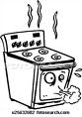](http://www.google.com.eg/imgres?imgurl=http://comps.fotosearch.com/comp/UNC/UNC311/appliance-burner-cartoon_~u25632682.jpg&imgrefurl=http://www.fotosearch.com/UNC311/u25632682/&usg=__6ISwkfRGxAA1RRmSqF-p1T4NBJY=&h=320&w=226&sz=25&hl=ar&start=15&zoom=1&tbnid=UWiKLEqa-45rUM:&tbnh=118&tbnw=83&ei=AWk4TaIhycDxA_b0la0I&prev=/images?q=oven+clip+art&hl=ar&sa=G&gbv=2&tbs=isch:1&itbs=1)**[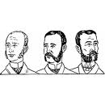](http://www.google.com.eg/imgres?imgurl=http://dclips.fundraw.com/zobo500dir/johnny_automatic_mens_hair_styles_circa_1900_-_4.jpg&imgrefurl=http://www.fundraw.com/clipart/clip-art/4678/Barbering-Manual:-Mens-Sideburns/&usg=__l2f0k6Rv9P13OAEavNZak8Zk-CE=&h=500&w=500&sz=38&hl=ar&start=2&zoom=1&tbnid=1dskm35rhNcK_M:&tbnh=130&tbnw=130&ei=5Gc4TZyUG8Ws8QPn2YSvCA&prev=/images?q=men+clip+art&hl=ar&sa=N&gbv=2&tbs=isch:1&itbs=1)[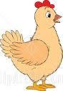](http://www.google.com.eg/imgres?imgurl=http://images.clipartof.com/small/31211-Clipart-Illustration-Of-A-Beige-Chicken-Hen-With-Red-On-Her-Head.jpg&imgrefurl=http://www.clipartof.com/details/clipart/31211.html&usg=__NSY7k0hRpTMLl4AQKT3dkp4khBU=&h=450&w=312&sz=55&hl=ar&start=4&zoom=1&tbnid=v9Lc-6H5gGFDsM:&tbnh=127&tbnw=88&ei=7GY4Tai9Ecil8QPczvicCA&prev=/images?q=hen+clip+art&hl=ar&sa=N&gbv=2&tbs=isch:1&itbs=1)[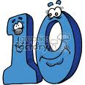](http://www.google.com.eg/imgres?imgurl=http://www.graphicsfactory.com/clip-art/image_files/image/0/1307440-numbers010c.gif&imgrefurl=http://www.graphicsfactory.com/Clip_Art/Letters/numbers010c_373605.html&usg=__WQ4kf1SVA6Zntzux6zWIdWb_C9Y=&h=300&w=300&sz=23&hl=ar&start=72&zoom=1&tbnid=NSDf30wK6UhOvM:&tbnh=116&tbnw=116&ei=Smc4TdL1NcKb8QPTx6GZCA&prev=/images?q=ten+clip+art&start=63&hl=ar&sa=N&gbv=2&tbs=isch:1&itbs=1)

………**en**

**Pen hen ten men oven**

Pen hen ten men oven

Pen hen ten men oven

Pen hen ten men oven

Pen hen ten men oven

Pen hen ten men oven

Pen hen ten men oven

Pen hen ten men oven

Pen hen ten men oven

Pen hen ten men oven

[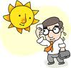](http://www.google.com.eg/imgres?imgurl=http://www.fotosearch.com/bthumb/UNC/UNC251/u10591574.jpg&imgrefurl=http://www.fotosearch.com/clip-art/hot-weather.html&usg=__nDQAzrWpsXi3RloP7zs5FzZFbhQ=&h=163&w=170&sz=10&hl=ar&start=2&zoom=1&tbnid=DiTSsvyC6orLnM:&tbnh=95&tbnw=99&ei=c2s4TbG9Jse48gP5zd2xCA&prev=/images?q=hot+clip+art&hl=ar&sa=N&gbv=2&tbs=isch:1&itbs=1)**[](http://www.google.com.eg/imgres?imgurl=http://www.clker.com/cliparts/f/f/e/2/1195431694965757905not_ok_mark_h_kon_l_vdal_03.svg.med.png&imgrefurl=http://www.clker.com/clipart-10792.html&usg=__dTv0mwgalekODZoZ_4c6_JmkI9Y=&h=300&w=300&sz=4&hl=ar&start=2&zoom=1&tbnid=RZNI6Cw8dOdUoM:&tbnh=116&tbnw=116&ei=w2w4TfbQC5DA8QPBpuGuCA&prev=/images?q=not+clip+art&hl=ar&sa=N&gbv=2&tbs=isch:1&itbs=1)**[http://t2.gstatic.com/images?q=tbn:f1p_CpxqUaHMmM:http://www.hasslefreeclipart.com/clipart_bodyparts/foot_100.jpg](http://www.google.com.eg/imgres?imgurl=http://www.hasslefreeclipart.com/clipart_bodyparts/foot_100.jpg&imgrefurl=http://www.hasslefreeclipart.com/clipart_bodyparts/page1.html&usg=__qOHnMdCxNWSldLoah5Lk3te0nGA=&h=74&w=100&sz=4&hl=ar&start=17&zoom=1&tbnid=f1p_CpxqUaHMmM:&tbnh=61&tbnw=82&ei=zG44TdTWHcOt8QPst_2vCA&prev=/images?q=foot+clip+art&hl=ar&sa=G&gbv=2&tbs=isch:1&itbs=1)

……**ot**

[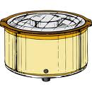](http://www.google.com.eg/imgres?imgurl=http://dclips.fundraw.com/zobo500dir/johnny_automatic_crockpot.jpg&imgrefurl=http://www.fundraw.com/clipart/clip-art/3337/Crock-Pot/&usg=__86wHllVWKcl3_vPHwM6Qh-lZ3FM=&h=500&w=500&sz=69&hl=ar&start=6&zoom=1&tbnid=0bDYZV1-cOIlSM:&tbnh=130&tbnw=130&ei=lWw4TZDLNYGW8QP-v_ybCA&prev=/images?q=pot+clip+art&hl=ar&sa=N&gbv=2&tbs=isch:1&itbs=1)

**hot dot not pot foot**

**hot dot not pot foot**

**hot dot not pot foot**

**hot dot not pot foot**

**hot dot not pot foot**

**hot dot not pot foot**

**hot dot not pot foot**

**hot dot not pot foot**

**hot dot not pot foot**

**hot dot not pot foot**

[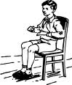](http://www.google.com.eg/imgres?imgurl=http://www.clker.com/cliparts/5/f/8/1/11971067231812192805johnny_automatic_boy_sitting_in_chair.svg.med.png&imgrefurl=http://www.clker.com/clipart-14728.html&usg=__gvtCjGmu-K9QNh9p4ly-0x2C2aw=&h=298&w=255&sz=25&hl=ar&start=3&zoom=1&tbnid=0ipITKLjitSzUM:&tbnh=116&tbnw=99&ei=xLU4TfXqOoeV8QP8nNmeCA&prev=/images?q=sit+clip+art&hl=ar&sa=X&noj=1&tbs=isch:1&prmd=ivns&itbs=1)[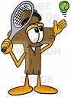](http://images.google.com.eg/imgres?imgurl=http://www.imageenvision.com/md/stock_photography/wooden_cross_cartoon_character_preparing_to_hit_a_tennis_ball.jpg&imgrefurl=http://www.imageenvision.com/stock_clipart/details/0025-0802-2319-4121/wooden_cross_cartoon_character_preparing_to_hit_a_tennis_ball&usg=__x0h844sCgCsXVXsbw38dkfWsLGg=&h=450&w=331&sz=50&hl=ar&start=12&um=1&tbnid=AtJmkkWt24_7YM:&tbnh=127&tbnw=93&prev=/images?q=hit++clipart&ndsp=18&hl=ar&sa=N&um=1)[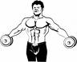](http://images.google.com.eg/imgres?imgurl=http://www.cksinfo.com/clipart/entertainment/fitness/Weight-Lifting-04.png&imgrefurl=http://www.cksinfo.com/entertainment/fitness/page2.html&usg=__5lM48CY5M3bZa6_TFJf9_v3LC8U=&h=122&w=150&sz=4&hl=ar&start=17&um=1&tbnid=kui598VF7tYBjM:&tbnh=78&tbnw=96&prev=/images?q=weight+lifting++clipart&hl=ar&um=1)[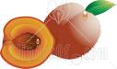](http://images.google.com.eg/imgres?imgurl=http://images.clipartof.com/small/19418-Clipart-Illustration-Of-A-Whole-Fuzzy-Peach-With-A-Green-Leaf-Beside-A-Cut-Peach-With-The-Pit-On-The-Inside.jpg&imgrefurl=http://www.clipartof.com/details/clipart/19418.html&usg=__ZOpv9sJrpPAX-GoIPTvGaPtx5bw=&h=267&w=450&sz=49&hl=ar&start=1&um=1&tbnid=ef36B-EVb_8MEM:&tbnh=75&tbnw=127&prev=/images?q=pit++clipart&hl=ar&um=1)

……**it**

**fit pit hit sit**

**fit pit hit sit**

**fit pit hit sit**

**fit pit hit sit**

**fit pit hit sit**

**fit pit hit sit**

**fit pit hit sit**

**fit pit hit sit**

**fit pit hit sit**

**fit pit hit sit**

……**ay**

[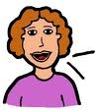](http://www.google.com.eg/imgres?imgurl=http://3.bp.blogspot.com/_RrxtlrxirJU/SintvMALXPI/AAAAAAAABqs/0HGIeEC6p30/s320/clipart+woman+talking.gif&imgrefurl=http://community.upromise.com/t5/FTD-Upromise-Mom-s-Advice/It-s-none-of-your-business-what-other-people-say-about-you/cns-p/11554&usg=__ZMQ2pLUbU064ADEV_zvcDSaDeQ0=&h=283&w=250&sz=12&hl=ar&start=4&zoom=1&tbnid=cw2dtTqXrDp5FM:&tbnh=114&tbnw=101&ei=QLo4Tc7rL4iW8QPxrfGeCA&prev=/images?q=say+clip+art&hl=ar&sa=N&gbv=2&tbs=isch:1&itbs=1)[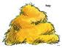](http://www.google.com.eg/imgres?imgurl=http://content.scholastic.com/content/media/products/63/0439353963_rgb010_sm.jpg&imgrefurl=http://printables.scholastic.com/printables/search/?Nty=0&_N=fff&Ntk=Printables_SI&query=walls&N=407&Ntt=walls&No=300&usg=__3dm0JUpEYAY47cJ2Y3ffgHIC9AU=&h=85&w=110&sz=35&hl=ar&start=45&zoom=0&tbnid=majNUV8RBxkN8M:&tbnh=66&tbnw=85&ei=M7k4TZqeKcaX8QOC5OSfCA&prev=/images?q=hay+clipart&start=42&hl=ar&sa=N&gbv=2&tbs=isch:1&itbs=1)[http://t2.gstatic.com/images?q=tbn:WoaiieyzAewUUM:http://www.clker.com/cliparts/J/t/1/Y/e/4/silver-tray-md.png](http://www.google.com.eg/imgres?imgurl=http://www.clker.com/cliparts/J/t/1/Y/e/4/silver-tray-md.png&imgrefurl=http://www.clker.com/clipart-silver-tray.html&usg=__dRHFnSIPL9-s-5rIQHxsYYvBOmo=&h=117&w=296&sz=19&hl=ar&start=97&zoom=1&tbnid=WoaiieyzAewUUM:&tbnh=46&tbnw=116&ei=G7w4TdDuBYWb8QPQxISfCA&prev=/images?q=tray+clip+art&start=84&hl=ar&sa=N&gbv=2&tbs=isch:1&itbs=1)[](http://www.google.com.eg/imgres?imgurl=http://classroomclipart.com/images/gallery/Clipart/Calendar/14-5-07-may-1.jpg&imgrefurl=http://classroomclipart.com/cgi-bin/kids/imageFolio.cgi?action=view&link=Clipart/Calendar&image=14-5-07-may-1.jpg&img=&tt=&usg=__j33m-ZJHXCtFGId9_hYS_lkotUI=&h=500&w=480&sz=68&hl=ar&start=9&zoom=1&tbnid=rUvBEVOwi721VM:&tbnh=130&tbnw=125&ei=qLs4TcCGO4mi8QPO0_ivCA&prev=/images?q=may+clip+art&hl=ar&sa=N&gbv=2&tbs=isch:1&itbs=1)[](http://www.google.com.eg/imgres?imgurl=http://images.all-free-download.com/images/graphicmedium/alcaline_spiral_calendar_clip_art_24441.jpg&imgrefurl=http://all-free-download.com/free-vector/vector-clip-art/calendar_clip_art_10971.html&usg=__egYqopAIuRdfBLfaAJAS6Eg6jcI=&h=200&w=200&sz=16&hl=ar&start=18&zoom=0&tbnid=DjV9Vv7eUiLenM:&tbnh=104&tbnw=104&ei=4ro4TaynHpOz8QOH-PSfCA&prev=/images?q=calendarclip+art&hl=ar&sa=N&gbv=2&tbs=isch:1&itbs=1)

**hay day say** **May tray**

**hay day say May tray**

**hay day say May tray**

**hay day say May tray**

**hay day say May tray**

**hay day say May tray**

**hay day say May tray**

**hay day say May tray**

**hay day say May tray**

**hay day say May tray**

…**all**

**[](http://www.google.com.eg/imgres?imgurl=http://www.freeclipartnow.com/d/16615-1/casual-call.jpg&imgrefurl=http://www.freeclipartnow.com/electronics-technology/phones/casual-call.jpg.html&usg=__igbb40d6V271kKwX5JxZdPLvUTQ=&h=336&w=350&sz=22&hl=ar&start=1&zoom=1&tbnid=bth6Eica2O3qPM:&tbnh=115&tbnw=120&ei=C8M4Tc7YDYOv8QO77oWpCA&prev=/images?q=call+clip+art&hl=ar&gbv=2&tbs=isch:1&itbs=1)**[](http://www.google.com.eg/imgres?imgurl=http://comps.fotosearch.com/comp/IMZ/IMZ318/small-man-document_~pix2032.jpg&imgrefurl=http://www.fotosearch.com/IMZ318/pix2032/&usg=__haEq1rH275Zm9_WQeXeMSyOn7Mk=&h=320&w=266&sz=24&hl=ar&start=1&zoom=1&tbnid=Db8ndJVX7OVSeM:&tbnh=118&tbnw=98&ei=vMQ4TbfHHIar8QPBpJWxCA&prev=/images?q=small+clip+art&hl=ar&sa=N&gbv=2&tbs=isch:1&itbs=1)[](http://www.google.com.eg/imgres?imgurl=http://www.clker.com/cliparts/3/7/d/5/1197103862376117882Gioppino_Soccer_Ball.svg.med.png&imgrefurl=http://www.clker.com/clipart-14508.html&usg=__7U6rlynz93qgG9aWfh9nXomep6k=&h=294&w=300&sz=34&hl=ar&start=3&zoom=1&tbnid=JkD4fuFLI-MdlM:&tbnh=114&tbnw=116&ei=hsQ4TbeIFYWt8gO2urShCA&prev=/images?q=ball+clip+art&hl=ar&sa=N&gbv=2&tbs=isch:1&itbs=1)[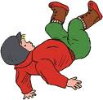](http://www.google.com.eg/imgres?imgurl=http://www.arthursclipart.org/accidents/accidents/boy%20fall.gif&imgrefurl=http://www.arthursclipart.org/accidents/accidents/page_01.htm&usg=__p9Dx8zvQDcPxXX9bA_wV-dFl_lw=&h=414&w=424&sz=24&hl=ar&start=186&zoom=1&tbnid=zs6VveNJMeSI3M:&tbnh=123&tbnw=126&ei=LsQ4TeCJCceg8QP3o8CtCA&prev=/images?q=fall+clip+art&start=168&hl=ar&sa=N&gbv=2&tbs=isch:1&itbs=1)[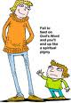](http://www.google.com.eg/imgres?imgurl=http://www.christart.com/IMAGES-art9aa/clipart/1967/tall-man-small-man.png&imgrefurl=http://www.christart.com/clipart/art_info/008844/1967/&usg=__ipO6UYe7osoRxeIzgAB7H6Lh4ys=&h=300&w=206&sz=53&hl=ar&start=7&zoom=1&tbnid=WnC0cpMBMRpNGM:&tbnh=116&tbnw=80&ei=usM4TbnNOoOb8QOwxuykCA&prev=/images?q=tall+clip+art&hl=ar&sa=N&gbv=2&tbs=isch:1&itbs=1)

**tall**  **ball fall call small**

**tall ball fall call small**

**tall ball fall call small**

**tall ball fall call small**

**tall ball fall call small**

**tall ball fall call small**

**tall ball fall call small**

**tall ball fall call small**

**tall ball fall call small**

**tall ball fall call small**

**tall ball fall call small**

..**oo**..

**[](http://www.google.com.eg/imgres?imgurl=http://www.free-clipart-pictures.net/free_clipart/book_clipart/book_clipart_3.gif&imgrefurl=http://www.free-clipart-pictures.net/book_clipart.html&usg=__zuWW0jx5AFo4_u3CVzIWFshFB44=&h=185&w=200&sz=4&hl=ar&start=3&zoom=1&tbnid=RmBfbJcMSM3HzM:&tbnh=96&tbnw=104&ei=sss4TbzPDIKr8QPshoGcCA&prev=/images?q=bookclip+art&hl=ar&sa=N&noj=1&tbs=isch:1&prmd=ivns&itbs=1)**[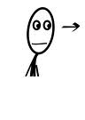](http://www.google.com.eg/imgres?imgurl=http://www.clker.com/cliparts/5/8/c/8/11954310821682401432paro_AL_look-right.svg.hi.png&imgrefurl=http://www.clker.com/clipart-10731.html&usg=__rGG4siKsNgzs8o1ABzbxqoVgsPM=&h=599&w=426&sz=19&hl=ar&start=2&zoom=1&tbnid=kJ2DC8a4JBLwPM:&tbnh=135&tbnw=96&ei=fcs4TczRK8Ok8QPGyIScCA&prev=/images?q=lookclip+art&hl=ar&sa=N&noj=1&tbs=isch:1&prmd=ivns&itbs=1)[](http://www.google.com.eg/imgres?imgurl=http://static0.arttoday.com/thm/thm1/CL/gc11/gcorp4/grldream/dream006.thm.jpg&imgrefurl=http://www.computerclipart.com/clipart_pages/clip_art/cook.shtml&usg=__TnA0GXQu3mXkEJ7Lt3P2El033ZI=&h=128&w=99&sz=6&hl=ar&start=33&zoom=0&tbnid=4uy_zy5Vd70FyM:&tbnh=91&tbnw=70&ei=TMs4Tdv4LIGg8QPy_L2sCA&prev=/images?q=cookclip+art&start=21&hl=ar&sa=N&noj=1&tbs=isch:1&prmd=ivns&itbs=1)[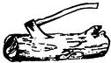](http://www.google.com.eg/imgres?imgurl=http://clipart.usscouts.org/library/Wood_Badge/logs/log_clipart_bw.gif&imgrefurl=http://imgspon.com/keyword/wood+clip+art&usg=__FRZoszXlGpnGFQaizyQV-QAHYUg=&h=250&w=437&sz=4&hl=ar&start=3&zoom=1&tbnid=EFHGf1TlEX-StM:&tbnh=72&tbnw=126&ei=Hss4TZH5PImo8QOC5cCrCA&prev=/images?q=woodclip+art&hl=ar&sa=X&noj=1&tbs=isch:1&prmd=ivns&itbs=1)[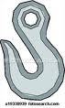](http://www.google.com.eg/imgres?imgurl=http://comps.fotosearch.com/comp/UNC/UNC113/chain-hook_~u19330939.jpg&imgrefurl=http://www.fotosearch.com/UNC113/u19330939/&usg=__NujL3r2z1qxUGdVfWyfpSx1teyI=&h=320&w=192&sz=20&hl=ar&start=7&zoom=1&tbnid=xM2B1AyPRkAO1M:&tbnh=118&tbnw=71&ei=2Mo4TbuBN5Or8QOckpymCA&prev=/images?q=hook+clip+art&hl=ar&sa=X&noj=1&tbs=isch:1&prmd=ivns&itbs=1)

**book look cook wood hook**

**book look cook wood hook**

**book look cook wood hook**

**book look cook wood hook**

**book look cook wood hook**

**book look cook wood hook**

**book look cook wood hook**

**book look cook wood hook**

**book look cook wood hook**

**book look cook wood hook**

**book look cook wood hook**

**book look cook wood hook**

**book look cook wood hook**

..**ou**..

..**oa**..

**[](http://www.google.com.eg/imgres?imgurl=http://www.clker.com/cliparts/f/7/e/b/11971485231218123211aritztg_Mouse.svg.hi.png&imgrefurl=http://www.clker.com/clipart-15768.html&usg=__zUHkT773_6UmUHL0VHDXhmVz4Gg=&h=400&w=600&sz=33&hl=ar&start=13&zoom=1&tbnid=XBH9Z9CBoUTRsM:&tbnh=90&tbnw=135&ei=atE4TbeFM4Oh8QORv9GmCA&prev=/images?q=mouse+clip+art&hl=ar&sa=N&noj=1&tbs=isch:1&prmd=ivns&itbs=1)[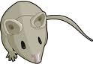](http://www.google.com.eg/imgres?imgurl=http://www.wisetome.com/splat/wp-content/uploads/2007/02/mousebig.png&imgrefurl=http://www.wisetome.com/splat/2007/02/06/free-clipart-mouse/&usg=__eBH9VjAMOGZc_wHyQ8L-t041Szg=&h=276&w=400&sz=41&hl=ar&start=10&zoom=1&tbnid=vR9gX0te3NtLxM:&tbnh=86&tbnw=124&ei=atE4TbeFM4Oh8QORv9GmCA&prev=/images?q=mouse+clip+art&hl=ar&sa=N&noj=1&tbs=isch:1&prmd=ivns&itbs=1)[](http://www.google.com.eg/imgres?imgurl=http://www.depauw.edu/photos/PhotoDB_Repository/2007/3/House%20Clip%20Art.gif&imgrefurl=http://www.depauw.edu/news/index.asp?id=23557&usg=__m3-qVmjwX2a1F-FTnAB8KJqcjUY=&h=236&w=250&sz=13&hl=ar&start=3&zoom=1&tbnid=NJf4n3jjPGeJjM:&tbnh=105&tbnw=111&ei=L9E4Tc79M9O48gPc6aypCA&prev=/images?q=house+clip+art&hl=ar&sa=N&noj=1&tbs=isch:1&prmd=ivns&itbs=1)[](http://www.google.com.eg/imgres?imgurl=http://www.clker.com/cliparts/9/e/2/3/1206575835462097843yves_guillou_boat.svg.med.png&imgrefurl=http://www.clker.com/clipart-boat1.html&usg=__NzaRtQSP8fMtc_pExvJqEisD4D4=&h=300&w=252&sz=14&hl=ar&start=2&zoom=1&tbnid=_P9bUR14A4-4WM:&tbnh=116&tbnw=97&ei=9dA4TbyiLY6o8QPN0ImfCA&prev=/images?q=boat+clip+art&hl=ar&sa=N&noj=1&tbs=isch:1&prmd=ivns&itbs=1)[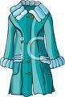](http://www.google.com.eg/imgres?imgurl=http://www.clipartguide.com/_named_clipart_images/0511-0811-2404-1150_Stylish_Winter_Coat_clipart_image.jpg&imgrefurl=http://www.clipartguide.com/_pages/0511-0811-2404-1150.html&usg=__8zLwmekc6eNQmJbBaLnjo9clLHI=&h=350&w=237&sz=84&hl=ar&start=15&zoom=1&tbnid=T_ad8pZKHFBZHM:&tbnh=120&tbnw=81&ei=ytA4TfydF4ys8QP9lemeCA&prev=/images?q=coat+clip+art&hl=ar&sa=N&noj=1&tbs=isch:1&prmd=ivns&itbs=1)[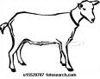](http://www.google.com.eg/imgres?imgurl=http://comps.fotosearch.com/comp/UNC/UNC103/goat_~u15528787.jpg&imgrefurl=http://www.fotosearch.com/UNC103/u15528787/&usg=__6w2jkBFfm7k1qngBMK2sO4lCMXQ=&h=235&w=300&sz=17&hl=ar&start=17&zoom=1&tbnid=RRX-TutYKOh56M:&tbnh=91&tbnw=116&ei=jNA4TdOWA5K08QOTqf2mCA&prev=/images?q=goat+clip+art&hl=ar&sa=N&noj=1&tbs=isch:1&prmd=ivns&itbs=1)**

**goat coat boat house mouse**

**goat c** **oat boat house mouse**

**g** **oat coat boat house mouse**

**goat c** **oat**  **boat house mouse**

**goat coat boat house mouse**

**g** **oa** **t coat boat house mouse**

**go** **at coat boat house mouse**

**goat coat boat house mouse**

**goat coat boat house mouse**

**goat coat boat house mouse**

**goat coat boat house mouse**

**goat coat boat house mouse**

..**sh**

**Sh**…

**[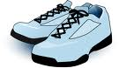](http://www.google.com.eg/imgres?imgurl=http://www.clker.com/cliparts/e/5/d/e/11949864391492944682tennis_shoes_jarno_vasam_.svg.hi.png&imgrefurl=http://www.clker.com/clipart-4222.html&usg=__MvXbBziu9QSkENmgmrt4EtDcVKY=&h=348&w=600&sz=84&hl=ar&start=1&zoom=1&tbnid=p3sMOJkPFjQleM:&tbnh=78&tbnw=135&ei=19Q4TcefHoGi8QPK3rmOCA&prev=/images?q=shoes+clip+art&hl=ar&sa=N&noj=1&tbs=isch:1&prmd=ivns&itbs=1)[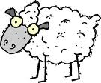](http://www.google.com.eg/imgres?imgurl=http://www.clker.com/cliparts/b/1/c/f/1195439362384130805ArtFavor_Cartoon_Sheep.svg.hi.png&imgrefurl=http://www.clker.com/clipart-11634.html&usg=__36_xiegERZPvTbCRHoK8a_b1YmI=&h=496&w=600&sz=61&hl=ar&start=3&zoom=1&tbnid=B3V7qjXfPhR2FM:&tbnh=112&tbnw=135&ei=otQ4TeSiIMWy8gPRh5yZCA&prev=/images?q=sheep+clip+art&hl=ar&sa=N&noj=1&tbs=isch:1&prmd=ivns&itbs=1)[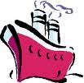](http://www.google.com.eg/imgres?imgurl=http://images.paraorkut.com/img/clipart/images/s/ship-83.gif&imgrefurl=http://www.graphicshunt.com/clipart/images/ship-83.htm&usg=__95oB4jDXWAlclpkW2XJNFyXgJ64=&h=190&w=194&sz=4&hl=ar&start=13&zoom=1&tbnid=Xq5PcokrgnIbhM:&tbnh=101&tbnw=103&ei=aNQ4TdDNIYKp8QP79ZmrCA&prev=/images?q=ship+clip+art&hl=ar&sa=N&noj=1&tbs=isch:1&prmd=ivns&itbs=1)[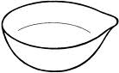](http://www.google.com.eg/imgres?imgurl=http://www.arthursclipart.org/science/science/evaporating%20dish.gif&imgrefurl=http://www.arthursclipart.org/science/science/page_02.htm&usg=__VN7QrUYIHD_lR6tiUH9CVLqUY8o=&h=408&w=661&sz=4&hl=ar&start=169&zoom=1&tbnid=Tu3tBP41pcr5FM:&tbnh=85&tbnw=138&ei=PNQ4TaHeMoig8QO5zLSeCA&prev=/images?q=dish+clip+art&start=168&hl=ar&sa=N&noj=1&tbs=isch:1&prmd=ivns&itbs=1)[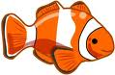](http://www.google.com.eg/imgres?imgurl=http://www.dailyclipart.net/wp-content/uploads/medium/clipart0048.jpg&imgrefurl=http://www.dailyclipart.net/clipart/clown-fish-clip-art/&usg=__jrUPkhZeajgm3Lmaek4LOIqUOXg=&h=223&w=340&sz=19&hl=ar&start=2&zoom=1&tbnid=sEZXURHvXvWpDM:&tbnh=78&tbnw=119&ei=9NM4TajEMZSo8QPIj6SkCA&prev=/images?q=fish+clip+art&hl=ar&sa=N&noj=1&tbs=isch:1&prmd=ivns&itbs=1)**

**fish dish ship sheep shoes**

**fish dish ship sheep shoes**

**fish dish ship sheep shoes**

**fish dish ship sheep shoes**

**fish dish ship sheep shoes**

**fish dish ship sheep shoes**

**fish dish ship sheep shoes**

**fish dish ship sheep shoes**

**fish dish ship sheep shoes**

**fish dish ship sheep shoes**

**fish dish ship sheep shoes**

**fish dish ship sheep shoes**

**fish dish ship sheep shoes**

..**ck**

**[](http://www.google.com.eg/imgres?imgurl=http://www.pixabella.com/wp-content/uploads/2009/08/black-heart.png&imgrefurl=http://www.pixabella.com/plugin/tag/heart-clipart&usg=__dSen3nHkYriHO8HSDLG1N6KQLME=&h=352&w=447&sz=9&hl=ar&start=17&zoom=1&tbnid=rLTVsusak6oAtM:&tbnh=100&tbnw=127&ei=UNc4Td3ZGsWt8gO9l8mfCA&prev=/images?q=black+clipart&hl=ar&sa=N&noj=1&tbs=isch:1&itbs=1)**[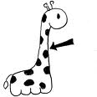](http://www.google.com.eg/imgres?imgurl=http://www.funfonix.com/clipart/neck.gif&imgrefurl=http://www.funfonix.com/clipart2.php&usg=__yjpzgKhl-zWF3AbD-gqRSgAeiUw=&h=300&w=300&sz=10&hl=ar&start=4&zoom=1&tbnid=Y0Q0QqEWi998zM:&tbnh=116&tbnw=116&ei=FNc4TcmKOsma8QO6qv2YCA&prev=/images?q=neck+clipart&hl=ar&sa=N&noj=1&tbs=isch:1&itbs=1)[](http://www.google.com.eg/imgres?imgurl=http://images.designheaven.com/freecontent/thumbs/001/christmas/christmas_070_01_thm.gif&imgrefurl=http://www.allfree-clipart.com/clipart/Holidays/Christmas/christmas-clipart5.html&usg=__O-fN1hidbqsg3dWduL2B0meyZuA=&h=100&w=95&sz=3&hl=ar&start=41&zoom=1&tbnid=yDPsOp5mk14oMM:&tbnh=82&tbnw=78&ei=xtY4TYa5FIay8gOIyPmfCA&prev=/images?q=sock+clip+art&start=21&hl=ar&sa=N&noj=1&tbs=isch:1&prmd=ivns&itbs=1)[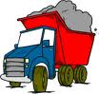](http://www.google.com.eg/imgres?imgurl=http://www.gzs-exim.sk/images/truck_clipart_4.gif&imgrefurl=http://www.gzs-exim.sk/nase_sluby.html&usg=__YUAIalTbO4sqGuvrTa1517ylYjU=&h=190&w=200&sz=12&hl=ar&start=3&zoom=1&tbnid=6dhPcNMug2v37M:&tbnh=99&tbnw=104&ei=iNY4TanQFc-28QOZ4ZipCA&prev=/images?q=truck+clip+art&hl=ar&sa=N&noj=1&tbs=isch:1&prmd=ivns&itbs=1)[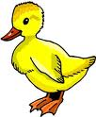](http://www.google.com.eg/imgres?imgurl=http://www.hinderthemnot.com/clip_art_duck.jpg&imgrefurl=http://www.ziizafon.com/vb/showthread.php?t=25454&usg=__SZ2An-AmPtxhHvEF2-bamZuHvwE=&h=400&w=329&sz=36&hl=ar&start=2&zoom=1&tbnid=zup0oUH-qFxS6M:&tbnh=124&tbnw=102&ei=XNY4TcGtO5K18QOnnJCrCA&prev=/images?q=duck+clip+art&hl=ar&sa=N&noj=1&tbs=isch:1&prmd=ivns&itbs=1)

**duck truck sock neck black**

**duck truck sock neck black**

**duck truck sock neck black**

**duck truck sock neck black**

**duck truck sock neck black**

**duck truck sock neck black**

**duck truck sock neck black**

**duck truck sock neck black**

**duck truck sock neck black**

**duck truck sock neck black**

**duck truck sock neck black**

**duck truck sock neck black**

**duck truck sock neck black**

..**ea..**

[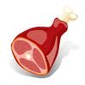](http://www.google.com.eg/imgres?imgurl=http://www.fotosearch.com/bthumb/CSP/CSP099/k0994816.jpg&imgrefurl=http://www.fotosearch.com/illustration/cut-meat.html&usg=__HvwQL--Yv0GqS6UXw7FiPKM4NY4=&h=170&w=170&sz=7&hl=ar&start=1&zoom=1&tbnid=f_TUo6Jiq_CjxM:&tbnh=99&tbnw=99&ei=GNo4TcmdOsia8QPBhI2ZCA&prev=/images?q=meat+clipart&hl=ar&sa=N&noj=1&tbs=isch:1&itbs=1)[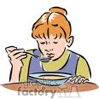](http://www.google.com.eg/imgres?imgurl=http://www.graphicsfactory.com/clip-art/image_files/image/3/1309303-hldn039.gif&imgrefurl=http://www.graphicsfactory.com/Clip_Art/People/Kids/hldn039_159198.html&usg=__R7grlo7AIt1vYZr4QL0YqvtxA4o=&h=300&w=300&sz=27&hl=ar&start=15&zoom=1&tbnid=v9XQtDnXXhsJrM:&tbnh=116&tbnw=116&ei=xdo4TdyhEYiW8QPxrfGeCA&prev=/images?q=eat+clipart&hl=ar&sa=N&noj=1&tbs=isch:1&itbs=1)

[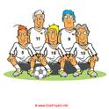](http://www.google.com.eg/imgres?imgurl=http://www.clipproject.info/Cliparts_Free/Fussball_Free/Clipart-Free-Gif-18.gif&imgrefurl=http://www.clipproject.info/Clipart_Fussball_Seite_4.html&usg=__y2dfxeKo3tlTw7S-iefKhfgKcpY=&h=400&w=400&sz=31&hl=ar&start=12&zoom=1&tbnid=40ES7Mz0u9WHjM:&tbnh=124&tbnw=124&ei=0dk4TY_LBI2s8QOqpIyxCA&prev=/images?q=team+clipart&hl=ar&sa=N&noj=1&tbs=isch:1&itbs=1)[http://t2.gstatic.com/images?q=tbn:aIbPH04-or5KGM:http://images.clipartof.com/thumbnails/26459-Clipart-Illustration-Of-The-String-Of-A-Tea-Bag-Hanging-Out-Of-A-Cup-Of-Hot-Tea-On-A-Saucer.jpg](http://www.google.com.eg/imgres?imgurl=http://images.clipartof.com/thumbnails/26459-Clipart-Illustration-Of-The-String-Of-A-Tea-Bag-Hanging-Out-Of-A-Cup-Of-Hot-Tea-On-A-Saucer.jpg&imgrefurl=http://www.clipartof.com/gallery/clipart/cup_of_tea.html&usg=__4Xg9ONurgZ7iFHtgmS1Qr6okC-w=&h=95&w=150&sz=9&hl=ar&start=41&zoom=1&tbnid=aIbPH04-or5KGM:&tbnh=61&tbnw=96&ei=mNo4TfyqOIea8QOF_5ymCA&prev=/images?q=teaclipart&start=21&hl=ar&sa=N&noj=1&tbs=isch:1&itbs=1)[http://t2.gstatic.com/images?q=tbn:epgXVEXsSVNgcM:http://www.clipartguide.com/_named_clipart_images/0511-0904-2220-4862_Kidney_Beans_clipart_image.jpg](http://www.google.com.eg/imgres?imgurl=http://www.clipartguide.com/_named_clipart_images/0511-0904-2220-4862_Kidney_Beans_clipart_image.jpg&imgrefurl=http://www.clipartguide.com/_pages/0511-0904-2220-4862.html&usg=__GqgYBJ4B_PEqKsWKLvm_tBV4txY=&h=182&w=350&sz=35&hl=ar&start=24&zoom=1&tbnid=epgXVEXsSVNgcM:&tbnh=62&tbnw=120&ei=Yto4TciiM4qV8QOUptylCA&prev=/images?q=bean+clipart&start=21&hl=ar&sa=N&noj=1&tbs=isch:1&itbs=1)[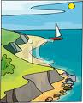](http://www.google.com.eg/imgres?imgurl=http://www.clipartguide.com/_named_clipart_images/0511-0806-0913-4713_Sailboat_on_the_Sea_clipart_image.jpg&imgrefurl=http://www.clipartguide.com/_pages/0511-0806-0913-4713.html&usg=__sYNwLpAycKejSalS5WfVtIzwFRc=&h=350&w=282&sz=87&hl=ar&start=1&zoom=1&tbnid=uAppyv8nbyRAwM:&tbnh=120&tbnw=97&ei=Kts4TeOcAoet8gOE_7CeCA&prev=/images?q=sea+clipart&hl=ar&sa=N&noj=1&tbs=isch:1&itbs=1)

**team meat bean tea eat sea**

**team meat bean tea eat sea**

**team meat bean tea eat sea**

**team meat bean tea eat sea**

**team meat bean tea eat sea**

**team meat bean tea eat sea**

**team meat bean tea eat sea**

**team meat bean tea eat sea**

**team meat bean tea eat sea**

**team meat bean tea eat sea**

**team meat bean tea eat sea**

**team meat bean tea eat sea**

**team meat bean tea eat sea**

**Ch**..

[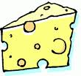](http://www.google.com.eg/imgres?imgurl=http://www.hasslefreeclipart.com/clipart_food/breakfast/cheese_swiss.gif&imgrefurl=http://www.hasslefreeclipart.com/clipart_food/cheese_swiss.html&usg=__zd4wGSMEsOe8Y6QTZ2RZrCvXUzM=&h=231&w=245&sz=11&hl=ar&start=9&zoom=1&tbnid=SfDfd3oHNm3b7M:&tbnh=104&tbnw=110&ei=Gd44TYipHsSo8AOo97yqCA&prev=/images?q=cheese+clipart&hl=ar&sa=N&noj=1&tbs=isch:1&itbs=1)[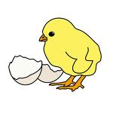](http://www.google.com.eg/imgres?imgurl=http://www.abcteach.com/free/c/chickneggrgb.jpg&imgrefurl=http://www.abcteach.com/directory/clip_art/holidays/easter/&usg=__fg5bpAVtNJBTuYD8G5_fs7oB5sY=&h=1200&w=1200&sz=111&hl=ar&start=2&zoom=1&tbnid=517DmZUWcBLAwM:&tbnh=150&tbnw=150&ei=kt04TZqKCces8gPkr7StCA&prev=/images?q=chick+clipart&hl=ar&sa=N&noj=1&tbs=isch:1&itbs=1)

[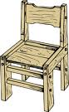](http://www.google.com.eg/imgres?imgurl=http://www.clker.com/cliparts/f/3/d/7/11954291422072351955johnny_automatic_wooden_chair.svg.hi.png&imgrefurl=http://www.clker.com/clipart-10537.html&usg=__WI8QFMg4zeqgZYnhfWQHFgwia7k=&h=592&w=366&sz=132&hl=ar&start=6&zoom=1&tbnid=YHF1M-0NBan85M:&tbnh=135&tbnw=83&ei=Pd44TdrkJMmb8QPE8OWrCA&prev=/images?q=chair+clipart&hl=ar&sa=N&noj=1&tbs=isch:1&itbs=1)[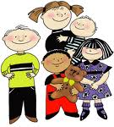](http://www.google.com.eg/imgres?imgurl=http://www.tirimoana.school.nz/Cache/Pictures/752921/6_children_clipart.jpg&imgrefurl=http://www.tirimoana.school.nz/Site/Weblinks_for_Kids_Parents_and_Teachers.ashx&usg=__QBAIYL5elISFfx2D-pUpizHFFok=&h=1024&w=925&sz=256&hl=ar&start=64&zoom=1&tbnid=2Bkf4WtZGjG3kM:&tbnh=150&tbnw=135&ei=4t04TfvOI9Gv8QPArMGrCA&prev=/images?q=children+clipart&start=63&hl=ar&sa=N&noj=1&tbs=isch:1&itbs=1)

**chick cheese children chair**

**chick cheese children chair**

**chick cheese children chair**

**chick cheese children chair**

**chick cheese children chair**

**chick cheese children chair**

**chick cheese children chair**

**chick cheese children chair**

**chick cheese children chair**

**chick cheese children chair**

**chick cheese children chair**