Bloom?s Taxonomy
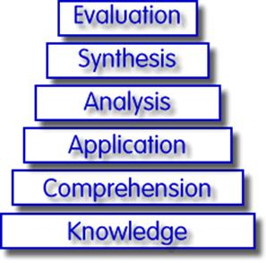

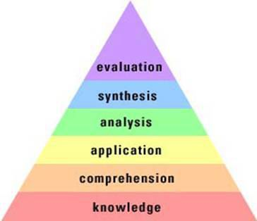

Applying Bloom?s Taxonomy

Knowledge

Useful Verbs | Sample Questions Stems | Potential Activities
tell  list  describe  relate  locate  write  find  state  name | What happened after ?? | Make a list of the main events
 | How many ? ? | Make a timeline of events .
 | Who was it that ?? | Make a fact chart .
 | Can you name the ?? | Write a list of any piece of information you can remember .
 | Describe what happened at ?? | List all the ?in the story
 | Who spoke to ?? | Make a chart showing?
 | Can you tell why ?? | Make an acrostic .
 | Find the meaning of ?? | Recite a poem
 | What is ? | ===
 | Which is true or false ?? | ===

Comprehension

Useful Verbs | Sample Questions Stems | Potential Activities
explain  interpret  outline  discuss  distinguish  predict  restate  translate  compare  describe | Can you write in your own words ?? | Cut out or draw pictures to show a particular event.
 | Can you write a brief outline ?? | Illustrate what you think the main idea was .
 | What do you think could of happened next ?? | Make a cartoon strip showing the sequence of events .
 | Who do you think ?? | Write & perform a play based on the story .
 | What was the main idea ?? | Retell the story in your words.
 | Who was the key character ?? | Paint a picture of some aspects you like .
 | Can you distinguish between ?? | write a summary report of an event.
 | What differences exist between ?? | Prepare a flow chart to illustrate the sequence of events.
 | Can you provide an example of what you mean ?? | Make a colouring book.
 | Can you provide a definition for ?? | ===
Application

Useful Verbs | Sample Questions Stems | Potential Activities
solve  show  use  illustrate  construct  complete  examine  classify | Do you know another instance where ?? | Construct a model to demonstrate how it will work .
 | Could this have happened in ?? | Make a diorama to illustrate an important event .
 | Can you group by characteristics as ?? | Make a scrapbook about the areas of study .
 | What factors would you change if ?? | Make a paper-mach map to include relevant information about the event.
 | Can you apply the method used to some experience of your own ?? | Take a collection of photographs to demonstrate a particular point .
 | What questions would you ask of ?? | Make up a puzzle game suing the ideas from the study area .
 | From the information given , can you develop a set of instructions about?? | Make a clay model of an item in the material .
 | Would this information be useful if you had a ?? | Design a market strategy for your own product using a known strategy as a model .
 | === | Dress a doll in national costume .
 | === | Paint a mural using the same materials .
 | === | Write a textbook about ?for others .

Analysis

Useful Verbs | Sample Questions Stems | Potential Activities
analyze  distinguish  examine  compare  contrast  investigate  categorize  identify  explain  separate  advertise | Which events could have happened ?? | Design a questionnaire to gather information .
 | What might the ending have been ?? | Write a commercial to sell a new product .
 | How was this similar to ?? | Conduct an investigation to produce information to support a view.
 | What was the underlying theme of ?? | Make a flow chart to show the critical stages.
 | What do you see as other possible outcomes ? | Construct a graph to illustrate selected information.
 | Why did ??changes occur ? | Make a jigsaw puzzle.
 | Can you compare your ?with that presented in ..? | Make a family tree showing relationships.
 | Can you explain what must have happened when ?? | Put on a play about the study area.
 | How is ?similar to ?? | Write a biography of the study person .
 | What are some of the problems of ?? | Prepare a report about the area of study .
 | Can you distinguish between ?? | Arrange a party. Make all the arrangements & record the steps needed.
 | What are some of the motives behind ?? | Review a work of art in terms of form ,colour & texture .
 | What was the turning point in the game ? | ===
 | What was the problem with?? | ===
Synthesis

Useful Verbs | Sample Questions Stems | Potential Activities
create  invent  compose  predict  plan  construct  design  imagine  propose  devise  formulate | Can you design a ? to ?? | Invent a machine to do a specific task .
 | Why not compose a ?about ?? | Design a building to house your study .
 | Can you see a possible solution to ?? | Create a new product . Give it a name & plan marketing campaign .
 | If you had access to all resources , how would you deal with ?? | Write about your feelings in relation to ?
 | Why don?t you devise your own way to deal with ?? | Write a TV show , play , puppet show or role play about ??
 | What would happen if ?? | Design a record , book , or magazine cover for ??
 | How many ways can you ?? | Make up a new language code and write material suing it .
 | Can you create new & unusual uses for ?? | Sell an idea .
 | Can you write a new recipe for a tasty dish ? | Devise a way to ?
 | Can you develop a proposal which would ?? | Compose a rhythm or put a new words to a known melody .

Evaluation

Useful Verbs | Sample Questions Stems | Potential Activities
judge  select  choose  decide  justify  debate  verify  argue  recommend  assess  discuss  rate  prioritize  determine | Is there a better solution to ?? | Prepare a list of criteria to judge a ?show .
 | Judge the value of ? | Indicate priority and ratings.
 | Can you defend your position about ?? | Conduct a debate about an issue of special interest .
 | Do you think ?is a good or a bad thing ? | Make a booklet about 5 rules you see important .
 | How would you have handled ?? | Convince others .
 | What changes to ?would you recommend ? | Form a panel to discuss a view , e.g. ? Learning at School.?
 | Do you believe ? | Write a letter to ?advising on changes needed at ?
 | Are you a ?person ? | Write a half yearly report .
 | How would you feel if ?? | Prepare a case to present your view about ?
 | How effective are ?? | ===
 | What do you think about ?? | ===

