Alice's Adventures Under Ground

by Lewis Carroll

Alice's Adventures Under Ground is a "facsimile" (shortened) version, the original manuscript and illustrations Charles Dodgson finished in 1864 for his friend, Alice Liddell, later published as the iconic fantasy novel for all ages, The Adventures of Alice in Wonderland (1865), using the pseudonym, Lewis Carroll. These original illustrations and handwritten texts are a real treasure, and remained in Liddell's possession until 1928, when she sold them at auction to pay her husband's debts. Purchased by an American art dealer and sold again, the manuscript was purchased by British benefactors in 1946 who donated it to the British people, installed at The British Museum in 1948, commemorating the end of World War II. [The photo of Alice Dodgson included in the manuscript (below) was not unveiled to the public until 1977.]
Carroll's shorter book is featured in our collection of Short Stories for Children
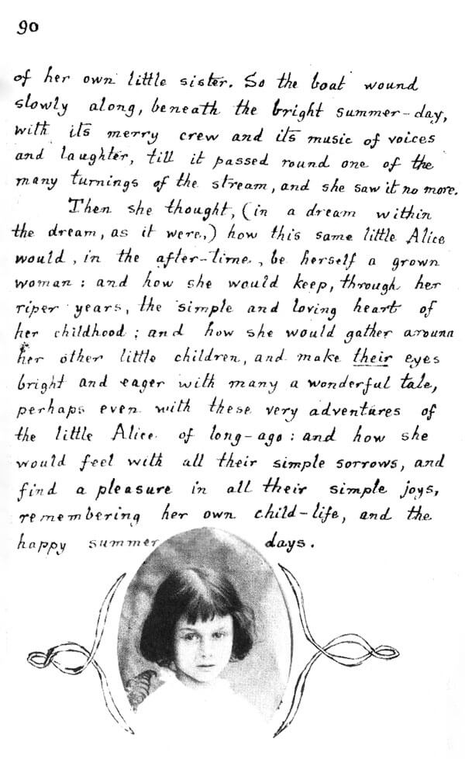

Chapter I - Down the Rabbit Hole. The Pool of Tears
Chapter II - A Long Tale. The Rabbit Sends in a Little Bill
Chapter III - Advice from a Caterpillar
Chapter IV - The Queen's Croquet-Ground. The Mock Turtle's Story. The Lobster's Quadrille
Postscript.
Who Will Riddle Me the How and Why?

