The Dogs And The Fox

by Aesop
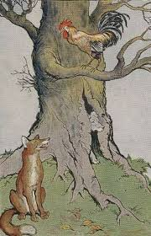

Some Dogs found the skin of a Lion and furiously began to tear it with their teeth. A Fox chanced to see them and laughed scornfully.
"If that Lion had been alive," he said, "it would have been a very different story. He would have made you feel how much sharper his claws are than your teeth."
It is easy and also contemptible to kick a man that is down.

The Dogs And The Fox

by Aesop

Some Dogs found the skin of a Lion and furiously began to tear it with their teeth. A Fox chanced to see them and laughed scornfully.
"If that Lion had been alive," he said, "it would have been a very different story. He would have made you feel how much sharper his claws are than your teeth."
It is easy and also contemptible to kick a man that is down.

