The Dog And The Oyster

by Aesop

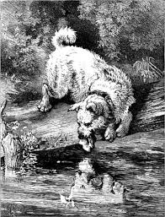

There was once a Dog who was very fond of eggs. He visited the hen house very often and at last got so greedy that he would swallow the eggs whole.
One day the Dog wandered down to the seashore. There he spied an Oyster. In a twinkling the Oyster was resting in the Dog's stomach, shell and all.
It pained the Dog a good deal, as you can guess.
"I've learned that all round things are not eggs," he said groaning.
Act in haste and repent at leisure—and often in pain.

The Dog And The Oyster

by Aesop

There was once a Dog who was very fond of eggs. He visited the hen house very often and at last got so greedy that he would swallow the eggs whole.
One day the Dog wandered down to the seashore. There he spied an Oyster. In a twinkling the Oyster was resting in the Dog's stomach, shell and all.
It pained the Dog a good deal, as you can guess.
"I've learned that all round things are not eggs," he said groaning.
Act in haste and repent at leisure—and often in pain.

