The Bundle Of Sticks

by Aesop

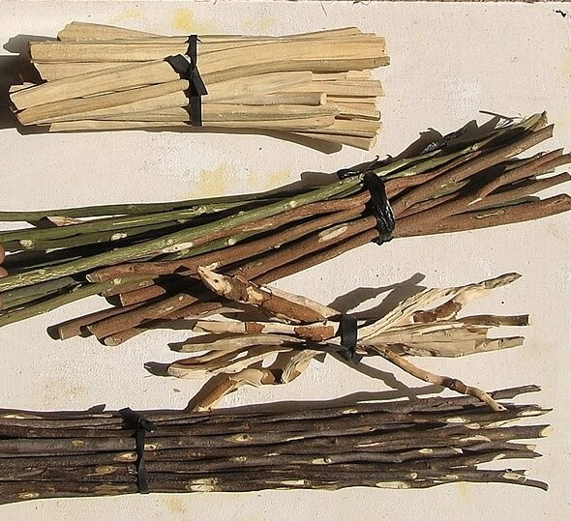T.K. Naliaka, Sticks Sold in Sahelian Markets, West Africa, 2015
A certain Father had a family of Sons, who were forever quarreling among themselves. No words he could say did the least good, so he cast about in his mind for some very striking example that should make them see that discord would lead them to misfortune.
One day when the quarreling had been much more violent than usual and each of the Sons was moping in a surly manner, he asked one of them to bring him a bundle of sticks. Then handing the bundle to each of his Sons in turn he told them to try to break it. But although each one tried his best, none was able to do so.
The Father then untied the bundle and gave the sticks to his Sons to break one by one. This they did very easily.
"My Sons," said the Father, "do you not see how certain it is that if you agree with each other and help each other, it will be impossible for your enemies to injure you? But if you are divided among yourselves, you will be no stronger than a single stick in that bundle."
In unity is strength.

The Bundle Of Sticks

by Aesop

T.K. Naliaka, Sticks Sold in Sahelian Markets, West Africa, 2015
A certain Father had a family of Sons, who were forever quarreling among themselves. No words he could say did the least good, so he cast about in his mind for some very striking example that should make them see that discord would lead them to misfortune.
One day when the quarreling had been much more violent than usual and each of the Sons was moping in a surly manner, he asked one of them to bring him a bundle of sticks. Then handing the bundle to each of his Sons in turn he told them to try to break it. But although each one tried his best, none was able to do so.
The Father then untied the bundle and gave the sticks to his Sons to break one by one. This they did very easily.
"My Sons," said the Father, "do you not see how certain it is that if you agree with each other and help each other, it will be impossible for your enemies to injure you? But if you are divided among yourselves, you will be no stronger than a single stick in that bundle."
In unity is strength.

