The Bat And The Weasels

by Aesop

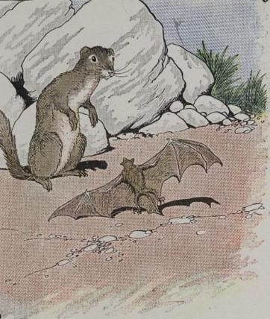
A Bat blundered into the nest of a Weasel, who ran up to catch and eat him. The Bat begged for his life, but the Weasel would not listen.
"You are a Mouse," he said, "and I am a sworn enemy of Mice. Every Mouse I catch, I am going to eat!"
"But I am not a Mouse!" cried the Bat. "Look at my wings. Can Mice fly? Why, I am only a Bird! Please let me go!"
The Weasel had to admit that the Bat was not a Mouse, so he let him go. But a few days later, the foolish Bat went blindly into the nest of another Weasel. This Weasel happened to be a bitter enemy of Birds, and he soon had the Bat under his claws, ready to eat him.
"You are a Bird," he said, "and I am going to eat you!"
"What," cried the Bat, "I, a Bird! Why, all Birds have feathers! I am nothing but a Mouse. 'Down with all Cats,' is my motto!"
And so the Bat escaped with his life a second time.
Set your sails with the wind.

The Bat And The Weasels

by Aesop

A Bat blundered into the nest of a Weasel, who ran up to catch and eat him. The Bat begged for his life, but the Weasel would not listen.
"You are a Mouse," he said, "and I am a sworn enemy of Mice. Every Mouse I catch, I am going to eat!"
"But I am not a Mouse!" cried the Bat. "Look at my wings. Can Mice fly? Why, I am only a Bird! Please let me go!"
The Weasel had to admit that the Bat was not a Mouse, so he let him go. But a few days later, the foolish Bat went blindly into the nest of another Weasel. This Weasel happened to be a bitter enemy of Birds, and he soon had the Bat under his claws, ready to eat him.
"You are a Bird," he said, "and I am going to eat you!"
"What," cried the Bat, "I, a Bird! Why, all Birds have feathers! I am nothing but a Mouse. 'Down with all Cats,' is my motto!"
And so the Bat escaped with his life a second time.
Set your sails with the wind.

